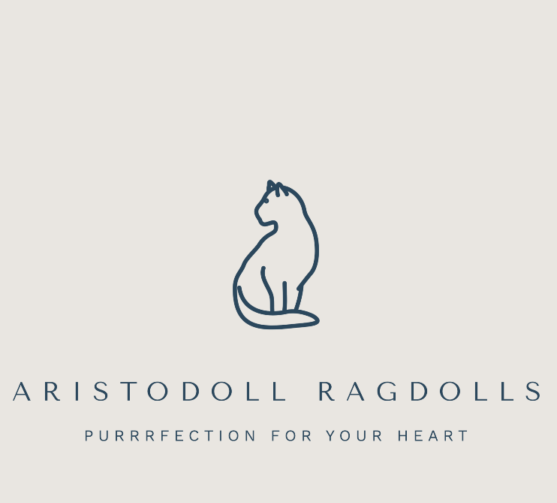

Aristodoll Ragdolls - Pre‑Screening Questionnaire for Rehoming a Retired Breeding Ragdoll
Welcoming an adult Ragdoll into your home is a meaningful commitment.
This questionnaire helps us learn more about you, your home, and your expectations so we can determine whether one of our retired Ragdolls would be a suitable match.
Please also feel free to visit our website for background information:
www.aristodollragdolls.com
Additional breed information can be found on the GCCF website.

Applicant Information
Name:
Contact Email:
Contact Number:
Location (UK):
Where did you find our contact details?
☐ GCCF website
☐ Progressive Ragdoll Breed Cat Club
☐ Referral by friend/family (please state):
☐ Other source (please state):

Your Experience & Expectations
- Have you previously owned a Ragdoll, a cat or any other pets? Please describe your experience.

- Why are you interested in rehoming a retired Ragdoll and what kind of home and lifestyle can you offer?

- Are you aware of the differences between adopting a retired breeding Ragdoll and adopting a kitten? For example: established personality, possible need for gradual socialisation, routine changes.

- How long would your Ragdoll be left alone during a typical day?

Your Household
- Who lives in your home (including children and other pets)?

- What type of home do you live in? (House, flat, rented, owned)

- Are you aware that Ragdolls are indoor‑only cats and should only have outdoor access via a secure catio, cat‑proof fencing, or on a lead?
☐ Yes
☐ No

- Do you or any household members have known allergies to cats?
☐ Yes
☐ No

- Are all household members committed to caring for your Ragdoll throughout their remaining lifetime?

Reflection Section
Please take time to consider the ongoing costs and responsibilities of caring for an adult Ragdoll, including:

- High‑quality food
- Litter and litter equipment
- Pet insurance
- Veterinary care
- Toys, bedding, grooming tools
- Annual vaccinations
- Monthly flea/worm treatments
- Holiday care arrangements (friends/family/cat sitter/cattery)

Submission
Please email your completed questionnaire or any questions to:
aristodoll@gmail.com

Once reviewed, if we feel you can offer a suitable home, we will contact you to discuss the next steps and arranging a potential viewing.

